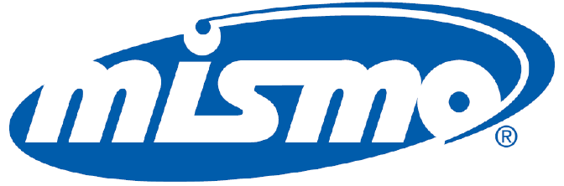

FundingShield: MISMO® Certification Success
MISMO has a certification program. There are multiple benefits to demonstrating that your company’s software is MISMO certified.
Enjoy this Q&A on MISMO Certification with FundingShield Founder and CEO Ike Suri
- What value is there in being MISMO certified?
FundingShield finds that being MISMO certified helps verify compliance with industry standards and showcases the best ways that the mortgage industry can work with each other.
We are the first and only MISMO certified wire and title fraud prevention fintech. Since joining MISMO two years ago we have been advocating, educating and promoting the need for the mortgage industry to address fraud/risk/compliance.
- What success are you achieving being MISMO certified?

Being a MISMO member and MISMO certified benefits FundingShield by bringing the company and our efforts into a very productive, collaborative forum with some of the smartest contributors in the industry.
- How is this helping you increase your business?
Being MISMO certified makes it easier to integrate with strategic partners and clients and has helped accelerate/increase our revenue.

- Any other benefits of MISMO membership and/or the MISMO certification end result?
The process to get MISMO certified is thorough and at the same time easy, efficient, and friendly. We encourage other MISMO participants to join us in being certified MISMO compliant.

For more information click here or email info@MISMO.org.

